Kindergarten Objectives for 1st Quarter:
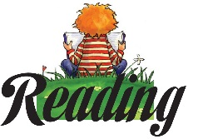
ELA (English, Language Arts) The students will: identify the front cover, back cover, and title of a book, describe the relationship between illustrations and the story, engage in group reading activities with purpose and understanding, actively engage in group reading activities, follow words from left to right, top to bottom, and page by page, recognize that spoken words are represented in written language by specific sequences of letters, and understand that words are separated by print.
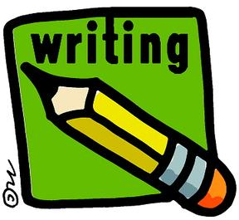
Writing: The students will use a combination of drawing, dictating and writing to narrate stories, follow agreed upon rules for discussions.
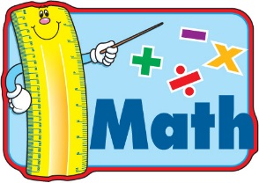
Math: count to 20, count to 100 by 10’s, write numbers to 10, compare numbers as more, less, or equal, count forward from any given number. You can help at home by incorporating these skills into your book time, homework, and daily activities.
Social studies: All about me, families. We are focusing on similarities and differences between families and each other. We are learning to follow agreed upon classroom rules.
Science: Properties of Objects, Five Senses

