**Homework Corner**

1). Linda’s Mask retell page

2). Math Pages: Detecting Dolphins Graph

3). Practice your lines for the play, speak loudly, slowly, and use expression! ☺

4). Big Universe

Upcoming Events

**June 14th –Mrs. Trybus’ Class: 11:30-12:30 EOY performance/picnic**

**June 15th –Mrs. Bruce’s Class: 11:30-12:30 EOY performance/picnic**

**June 29th- Last day of school**

Friday, January 18

**Report Cards**

Friday, January 25

Our end of the year program/picnic is scheduled for June 14th (Trybus) or 15th (Bruce). Please continue to help your child practice his/her lines and find a costume. We are so excited and proud of all the kiddos for how well they did on their end of year assessments! Thank you to everyone for helping make this a wonderful year in Kindergarten! ☺

Matias is Star Student next week!

Here are our highlights:

Theme: Animals/Bug/Insects

Letterland: Word Families/Blends

Kindergarten Objectives for 4th Quarter:

ELA (English, Language Arts)

This week we have been continuing our animal study. The children are learning about life cycles, animal habitats, and the food chain.

Writing:

This week we wrote a personal narrative and an opinion piece about insects and animals. The students did a wonderful job on their unassisted writing this week! ☺

Math:

We are continuing to work on math centers. We are reviewing math mountains, measuring, tens and ones, and subtraction.

Science:

Animal homes and habitats/life cycles



### Olive Chapel Elementary School

June 8, 2018

kbruce@wcpss.net

ctrybus@wcpss.net

Track 3 Tidbits

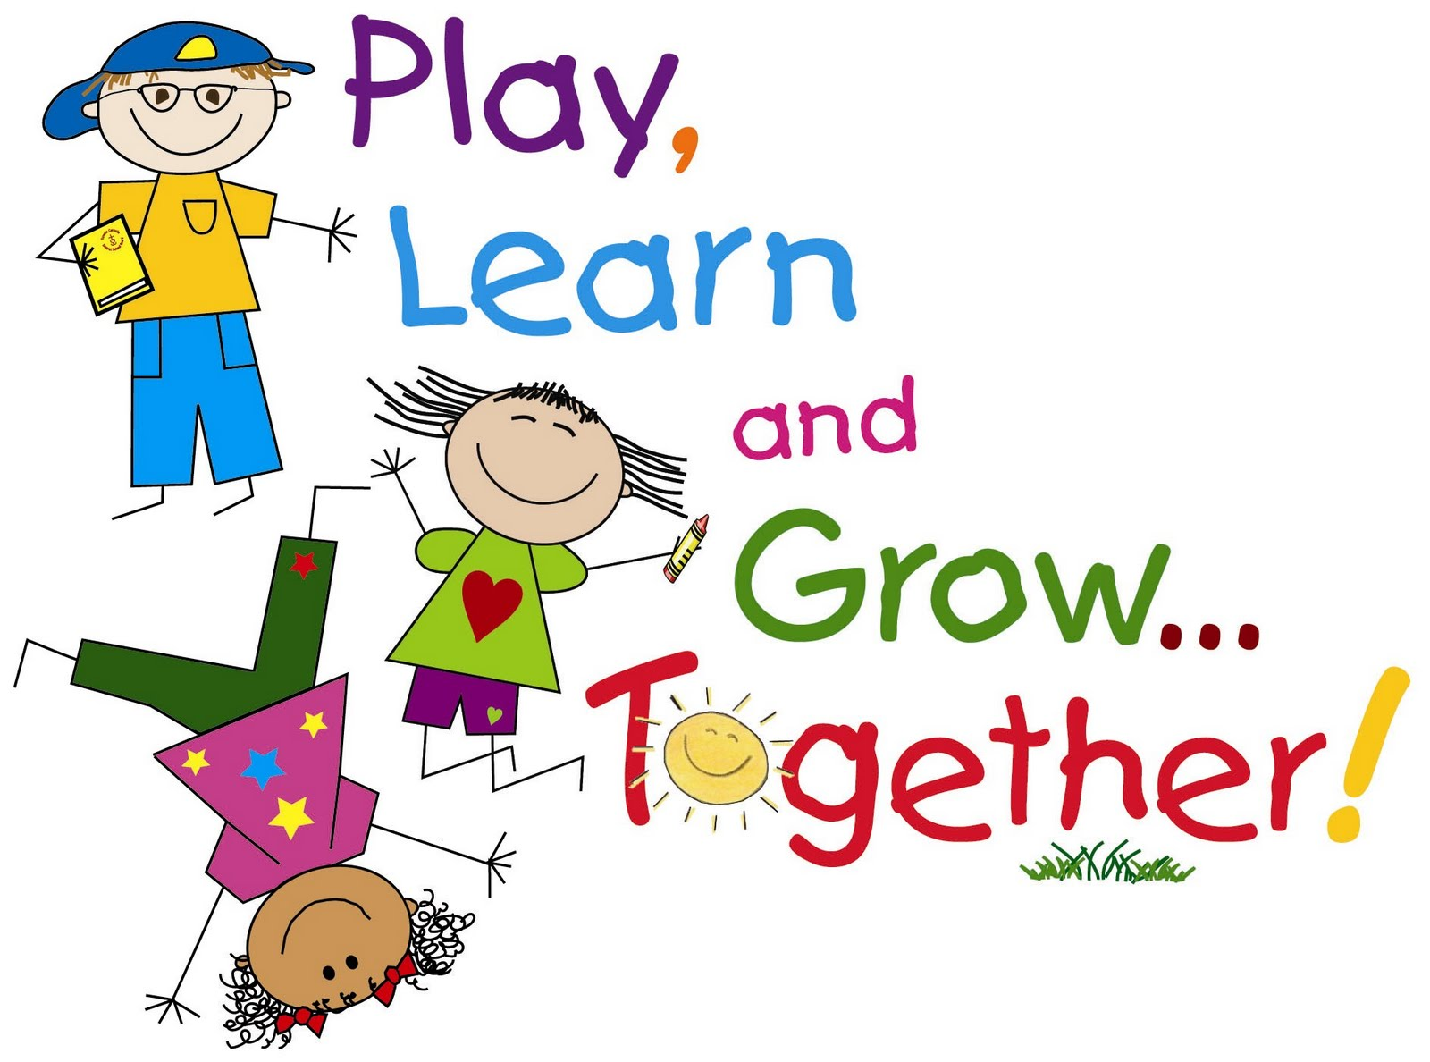

# Teacher’s Corner

Kindergarten News

**This Weeks Highlights**